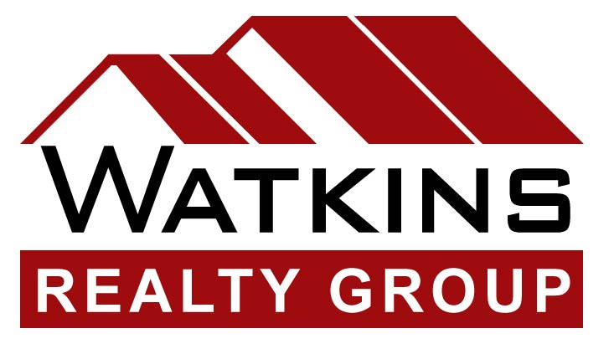

September 29, 2008

John and Cecelia Lopez
6778 Potomac Street
San Diego, CA 92139

Dear John and Cecelia,

Greetings! How are you both?

I wanted to give you an update on my career. This past year I obtained my California Real Estate License and completed an intense real estate training program. I joined an excellent real estate company called Watkins Realty Group, which has offices in both North County and the South Bay. We also have a mortgage division called Watkins Home Loans.

With this recent training and work experience, I feel very confident about being able to help buyers and sellers with their real estate needs. My goal is to be a very knowledgeable real estate professional and provide the best possible service to the clients I serve.

If you know of at least one person who is thinking about buying or selling property, I would appreciate you giving them my name. I will do everything I can to meet their real estate needs. I've included a few business cards for your convenience.

Please let me know if I can ever be of assistance to you. You can also check out real estate information on our website at www.watkinsrealtygroup.com.

I'll be talking to you soon!

Sincerely,

Joanne Moore, Realtor
Watkins Realty Group
Cell: 619-920-7355

